Filesystem

All data store on a computer is organized into directories and files.

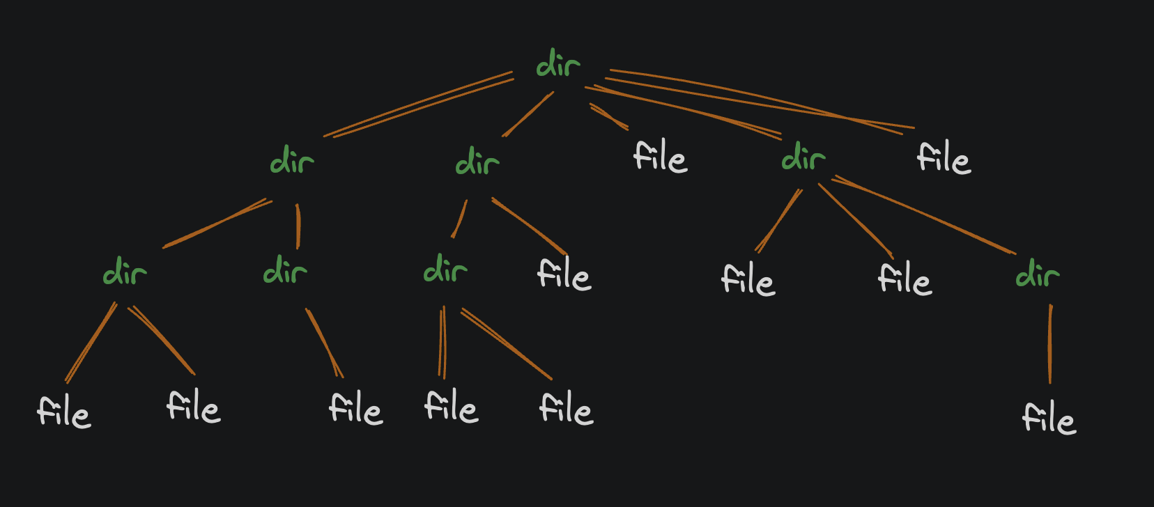

**Directories:** are containers that hold other directories and files. (in windows directories is called folder)

**Files**: is a dump of raw binary date: 0’s and 1’s (the bites in a file can represent anything: text, images, video, etc.

The tree starts from **root directory.**

When opening your terminal; its usually your **home directory.**

***Run the "print working directory" command to see the filepath of your current working directory:***

***pwd***

results: **/home/codemaster**

**Filepaths**

The output of pwd is a *filepath*. A filepath is a string that describes the location of a file or directory on your computer. Yours should look *something* like this:

**/home/codemaster or /Users/wagslane**

The text might be different, but the structure should be the same. Let's break it down:

* The first slash (/) represents the *root directory*. It's the tippy-top of the filesystem tree.
* The next part (Users) is the name of a directory inside the root directory.
* Finally, the last part (wagslane) is the name of a directory inside the Users directory.

So this path represents a directory 2 levels down from the root directory:

root (root directory)

└── Users (directory inside roots directory)

└── wagslane (directory inside the users directory)

**/home/codemaster**

/(root)

home(home directory inside root)

codemaster(directory inside home directory)

"C:\Users\vetle\Desktop\to gittttt\Fix the math bug.py"

The name of last place on the path is written last: Fix the math bug.py

* /home = parent folder for all users
* /home/codemaster = *your personal* home directory